Office of the Dean
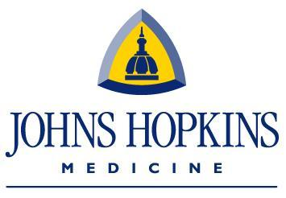
Research Administration
Miller Research Building
733 N. Broadway, Suite 117
Baltimore, Maryland 21205
410-955-3061 T
410-502-7832 F

[DOUBLE-CLICK THE GREY BOXES TO ENTER TEXT. (Delete this box)]

STATEMENT OF INTENT TO ESTABLISH A CONSORTIUM AGREEMENT

Date:

Prime Grant PI:
Prime Grant Institution:
Sub Grant PI:
Application Title:
Proposed Project Period: 2/1/15 - 1/31/15

Subgrant Institution requested dollars:

First Year |  | All Years
Direct Costs |  | Direct Costs
F&A Costs |  | F&A Costs
Total Costs |  | Total Costs

Are Animals Applicable to this Proposed Project? Yes No

Are Humans Applicable to this Proposed Project? Yes No

The appropriate programmatic and administrative personnel of each institution involved in this grant application are aware of the pertinent Federal regulations and policies and are prepared to establish written inter-organizational agreements that will ensure compliance with all such policies.

_________________________________________ _______________
Signature of Signing Authority Date

Printed Name:
Title:

Contact for negotiation and execution of consortium agreement
Name:
Title:

Address: 733 N. Broadway, Suite 117, Baltimore, MD 21205
Telephone:
Fax: 410-502-7832
E-mail:

